**Exercise 4 : Exploring Regression Performance with kernel functions**

**Date: 28/10/2024**

**AIM:**

To explore regression performance with different kernel functions and analyze the impact of kernel matrix operations on dataset patterns and relationships.

**CODE:**

from sklearn.datasets import load_breast_cancer

import matplotlib.pyplot as plt

from sklearn.inspection import DecisionBoundaryDisplay

from sklearn.svm import SVC,SVR

import pandas as pd

import numpy as np

from sklearn.model_selection import train_test_split

from sklearn.preprocessing import StandardScaler

from sklearn.metrics import classification_report,confusion_matrix,accuracy_score

cancer=load_breast_cancer()

cancer.keys()

dict_keys(['data', 'target', 'frame', 'target_names', 'DESCR', 'feature_names', 'filename', 'data_module'])

X=cancer.data[:,:2]

y=cancer.target

svm = SVC(kernel="rbf", gamma=0.5, C=1.0)

svm.fit(X, y)

DecisionBoundaryDisplay.from_estimator(svm,X,response_method="predict",cmap=plt.cm.Spectral,alpha=0.8,xlabel=cancer.feature_names[0],ylabel=cancer.feature_names[1],)

plt.scatter(X[:,0], X[:,1], c=y,s=20, edgecolors="k")

plt.show()

**OUTPUT:**

X=np.sort(5*np.random.rand(40,1),axis=0)

y=np.sin(X).ravel()

y[::5]+=3*(0.5-np.random.rand(8))

svr=SVR(kernel='poly')

svr.fit(X,y)

y_pred = svr.predict(X)

plt.scatter(X,y,color='darkorange',label='data')

plt.plot(X,y_pred,color='cornflowerblue',label='prediction')

plt.legend()

plt.show()

**OUTPUT:**

**CODE:**

data=pd.read_csv("/content/data.csv")

data=data.drop(columns=['id'],axis=1)

data.info()

**CODE:**

data['diagnosis']=data['diagnosis'].map({'M':1,'B':0})

X=data.drop('diagnosis',axis=1)

y=data['diagnosis']

X_train,X_test,y_train,y_test=train_test_split(X,y,test_size=0.3,random_state=42)

scaler=StandardScaler()

X_train=scaler.fit_transform(X_train)

X_test=scaler.transform(X_test)

rbf_model=SVC(kernel='rbf')

rbf_model.fit(X_train, y_train)

y_pred=rbf_model.predict(X_test)

print(confusion_matrix(y_test, y_pred))

print(classification_report(y_test, y_pred))

accuracy = accuracy_score(y_test, y_pred)

print(f'Accuracy: {accuracy:.4f}')

**OUTPUT:**

**CODE:**

linear_model=SVC(kernel='linear')

linear_model.fit(X_train, y_train)

y_pred=linear_model.predict(X_test)

print(confusion_matrix(y_test, y_pred))

print(classification_report(y_test, y_pred))

accuracy = accuracy_score(y_test, y_pred)

print(f'Accuracy: {accuracy:.4f}')

**OUTPUT:**

**CODE:**

poly_model=SVC(kernel='poly')

poly_model.fit(X_train, y_train)

y_pred=poly_model.predict(X_test)

print(confusion_matrix(y_test, y_pred))

print(classification_report(y_test, y_pred))

accuracy = accuracy_score(y_test, y_pred)

print(f'Accuracy: {accuracy:.4f}')

**OUTPUT:**

**CODE:**

sigmoid_model=SVC(kernel='sigmoid')

sigmoid_model.fit(X_train, y_train)

y_pred=sigmoid_model.predict(X_test)

print(confusion_matrix(y_test, y_pred))

print(classification_report(y_test, y_pred))

accuracy = accuracy_score(y_test, y_pred)

print(f'Accuracy: {accuracy:.4f}')

**OUTPUT:**

**CODE:**

def gaussian_kernel_matrix(X, sigma):

distances=np.sum((X[:,np.newaxis]-X)**2,axis=-1)

kernel_matrix=np.exp(-distances/(2 *sigma**2))

return kernel_matrix

sigma=1.00

**CODE:**

X=data.values

kernel_matrix=gaussian_kernel_matrix(X,sigma)

print(x.shape,kernel_matrix.shape)

**OUTPUT:**



**CODE:**

print("Kernel matrix:")

print(kernel_matrix)

**OUTPUT:**

**RESULT:**

Regression analysis revealed varying performance across linear, polynomial, and RBF kernels, with kernel matrix operations highlighting distinct relationships within the data, aiding in understanding each kernel’s effectiveness.

**Exercise 5 : Exploring Dimensionality Reduction Techniques**

**Date : 9/10/2024**

**AIM:**

To implement the Page Rank algorithm to determine the importance of web pages based on the quantity and quality of links

**CODE:**

import pandas as pd

import numpy as np

import matplotlib

import matplotlib.pyplot as plt

import seaborn as sns

from sklearn.decomposition import PCA

from sklearn.preprocessing import StandardScaler

from sklearn.datasets import load_boston

from sklearn.linear_model import LinearRegression

from sklearn.feature_selection import RFE

# loading dataset into Pandas DataFrame

iris_url = "http4s://archive.ics.uci.edu/ml/machine-learning-databases/iris/iris.data"

df_iris = pd.read_csv(iris_url, names=['sepal length','sepal width','petal length','petal width','target'])

df_iris.head(15)

**OUTPUT:**

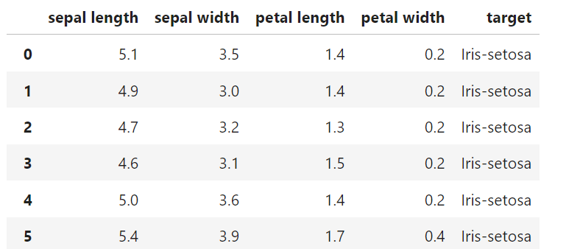

**CODE:**

sns.pairplot(df_iris, hue='target')

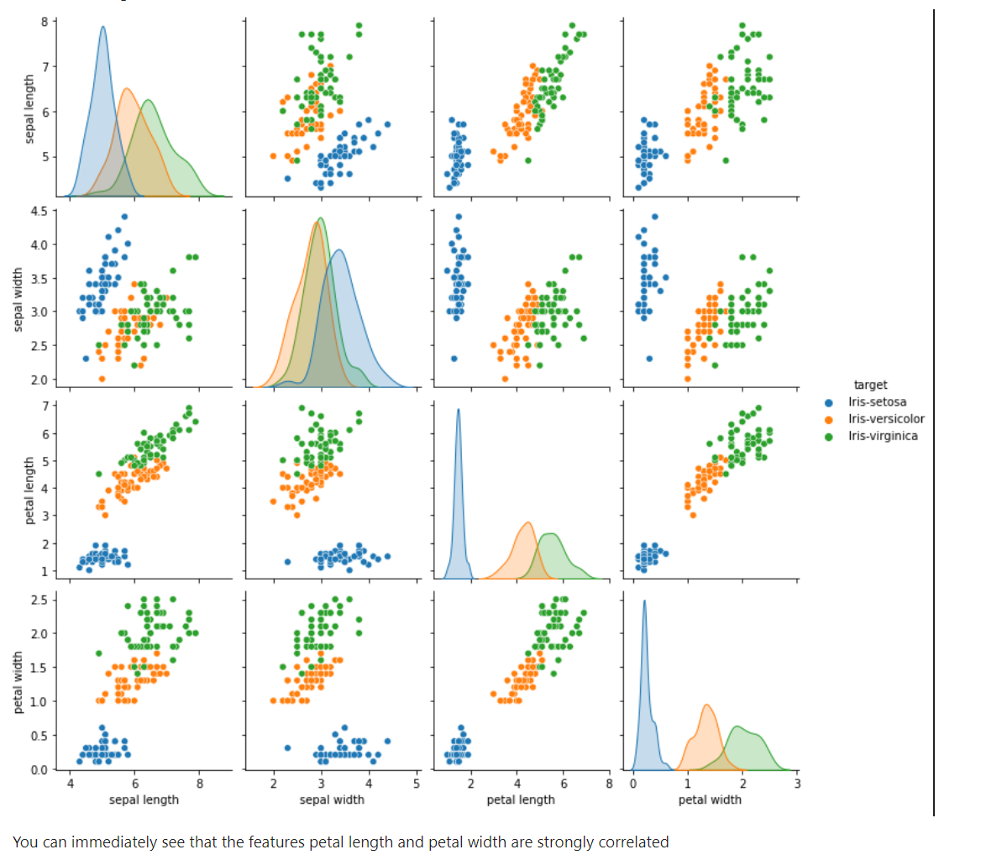

**CODE:**

features_iris = ['sepal length', 'sepal width', 'petal length', 'petal width']

x_iris = df_iris.loc[:, features_iris].values

y_iris = df_iris.loc[:, ['target']].values

x_iris = StandardScaler().fit_transform(x_iris)

df_iris_standarize = pd.DataFrame(data = x_iris, columns = features_iris)

df_iris_standarize['target'] = df_iris['target']

df_iris_standarize.head(15)

**PCA Projection to 2D:**

pca_iris = PCA(n_components=2)

principalComponents_iris = pca_iris.fit_transform(x_iris)

principalDf_iris = pd.DataFrame(data = principalComponents_iris ,columns = ['principal component 1', 'principal component 2'])

finalDf_iris = pd.concat([principalDf_iris, df_iris[['target']]], axis = 1)

finalDf_iris.head(15)

**OUTPUT:**

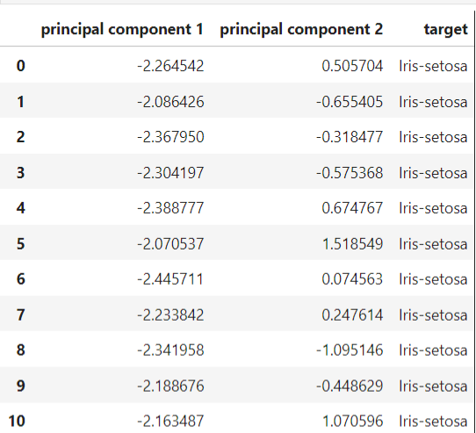

**CODE:**

fig = plt.figure(figsize = (8,8))

ax = fig.add_subplot(1,1,1)

ax.set_xlabel('Principal Component 1', fontsize = 15)

ax.set_ylabel('Principal Component 2', fontsize = 15)

ax.set_title('2 Component PCA', fontsize = 20)

iris_targets = ['Iris-setosa', 'Iris-versicolor', 'Iris-virginica']

colors = ['r', 'g', 'b']

for target, color in zip(iris_targets,colors):

indicesToKeep = finalDf_iris['target'] == target

ax.scatter(finalDf_iris.loc[indicesToKeep, 'principal component 1']

, finalDf_iris.loc[indicesToKeep, 'principal component 2']

, c = color

, s = 50)

ax.legend(iris_targets)

ax.grid()

**OUTPUT:**

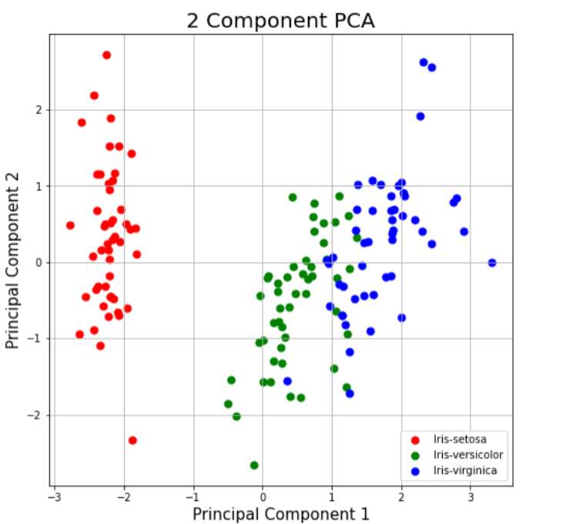

**CODE:**

pca_iris.explained_variance_ratio_

from sklearn.datasets import load_breast_cancer

breast_cancer = load_breast_cancer()

print(f"Breast cancer dataset type: {type(breast_cancer)}")

# sklearn.utils.Bunch -> pandas.DataFrame

df_bc = pd.DataFrame(data=breast_cancer.data, columns=breast_cancer.feature_names)

df_bc['target'] = breast_cancer.target

df_bc['target'] = df_bc['target'].apply(lambda x: 'benign' if x == 0 else 'malignant')

df_bc.head()

**OUTPUT:**

**CODE:**

dataplot = sns.heatmap(df_bc.corr())

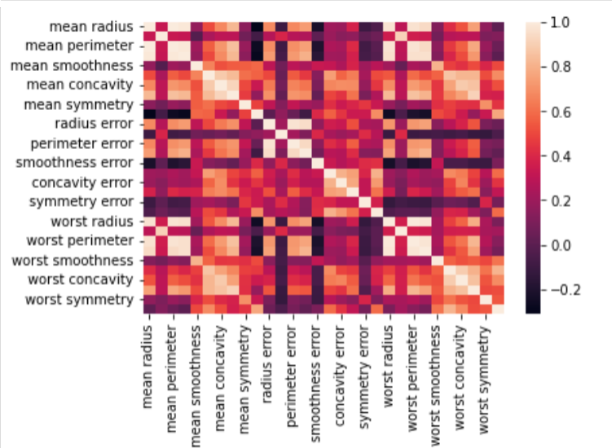

**CODE:**

# pandas.core.indexes.base.Index -> List

features_breast_cancer = df_bc.columns.tolist()

features_breast_cancer = features_breast_cancer[:-1] # Skip target

x_breast_cancer = df_bc.loc[:, features_breast_cancer].values

y_breast_cancer = df_bc.loc[:, ['target']].values

# Standarization

print(type(x_breast_cancer))

x_breast_cancer = StandardScaler().fit_transform(x_breast_cancer)

# Werifization of standarization - standard deviation == 1 and mean == 0.

x_breast_cancer.std(axis=0)

df_bc_standarize = pd.DataFrame(data=x_breast_cancer, columns=features_breast_cancer)

df_bc_standarize['target'] = df_bc['target']

**Perform PCA to reduce dimensionality of breast cancer dataset:**

**CODE:**

principalComponents_breast_cancer= pca_breast_cancer.fit_transform(x_breast_cancer)

principalDf_breast_cancer_columns = ['principal component 1', 'principal component 2']

principalDf_breast_cancer = pd.DataFrame(data=principalComponents_breast_cancer, columns=principalDf_breast_cancer_columns)

finalDf_breast_cancer = pd.concat([principalDf_breast_cancer, df_bc[['target']]], axis=1)

finalDf_breast_cancer.head()

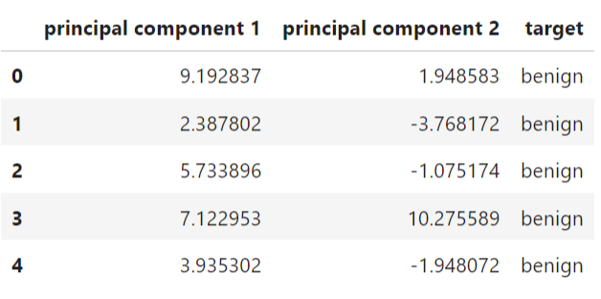

**CODE:**

variance_ratio = pca_breast_cancer.explained_variance_ratio_

plt.title("Projection by variance")

plt.plot(variance_ratio, 'ro')

plt.xlabel('Number of components')

plt.ylabel('Cumulative explained variance')

plt.show()

print(f"Principal Component 1 explains {variance_ratio[0] * 100}% of total variance.")

print(f"Principal Component 2 explains {variance_ratio[1] * 100}% of total variance.")

print(f"Dimensionality reducion from {len(df_bc.columns)-1} to {len(variance_ratio)} "

f"leaves {sum(variance_ratio) * 100}% of total variance.")

**OUTPUT:**

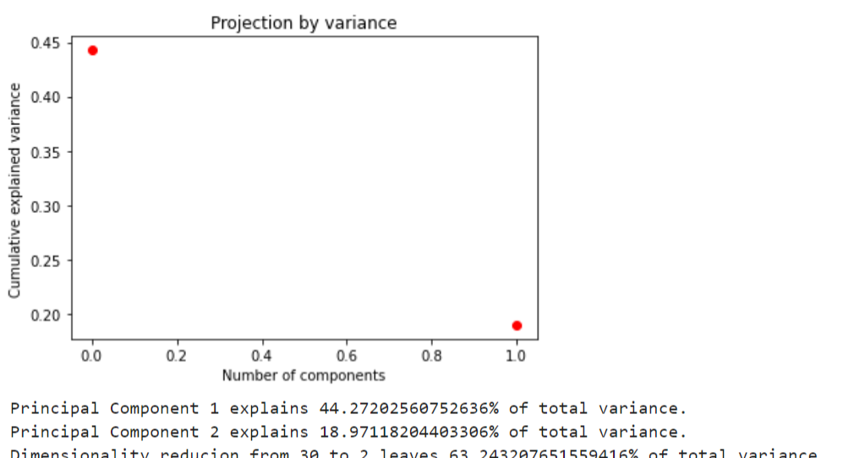

**CODE:**

fig = plt.figure(figsize = (8,8))

ax = fig.add_subplot(1,1,1)

ax.set_xlabel('Principal Component 1', fontsize = 15)

ax.set_ylabel('Principal Component 2', fontsize = 15)

ax.set_title('2 Component PCA', fontsize = 20)

breast_cancer_targets = ['benign', 'malignant']

colors = ['r', 'g']

for target, color in zip(breast_cancer_targets, colors):

indicesToKeep = finalDf_breast_cancer['target'] == target

ax.scatter(finalDf_breast_cancer.loc[indicesToKeep, 'principal component 1'],

finalDf_breast_cancer.loc[indicesToKeep, 'principal component 2'],

c = color,

s = 50)

ax.legend(breast_cancer_targets)

ax.grid()

**OUTPUT:**

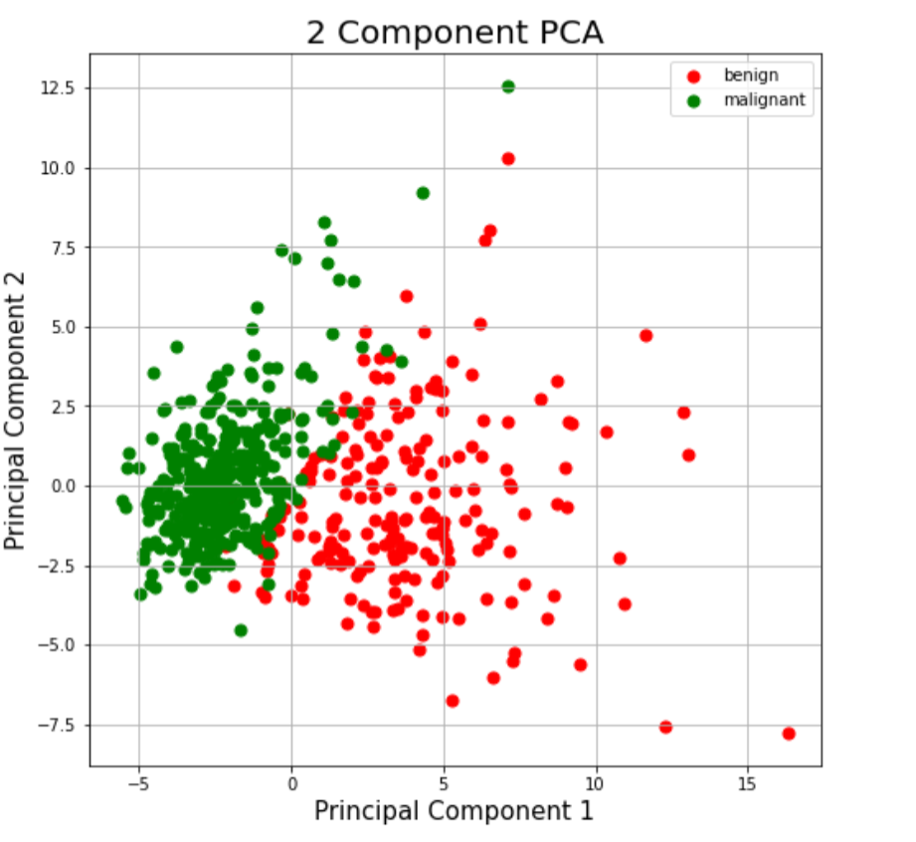

**Kernel PCA:**

import matplotlib.pyplot as plt

from sklearn.datasets import make_moons

X, y = make_moons(n_samples = 500, noise = 0.02, random_state = 417)

plt.scatter(X[:, 0], X[:, 1], c = y)

plt.show()

**OUTPUT:**

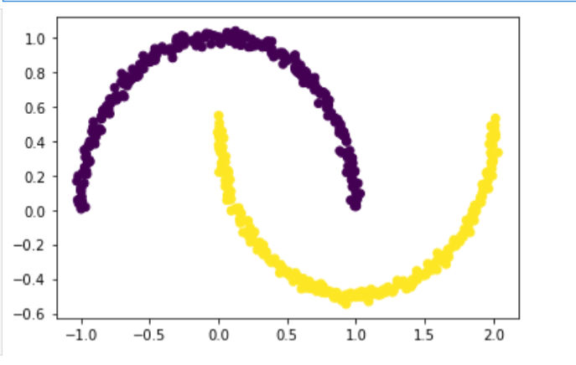

**CODE:**

pca = PCA(n_components = 2)

X_pca = pca.fit_transform(X)

plt.title("PCA")

plt.scatter(X_pca[:, 0], X_pca[:, 1], c = y)

plt.xlabel("Component 1")

plt.ylabel("Component 2")

plt.show()

**OUTPUT:**

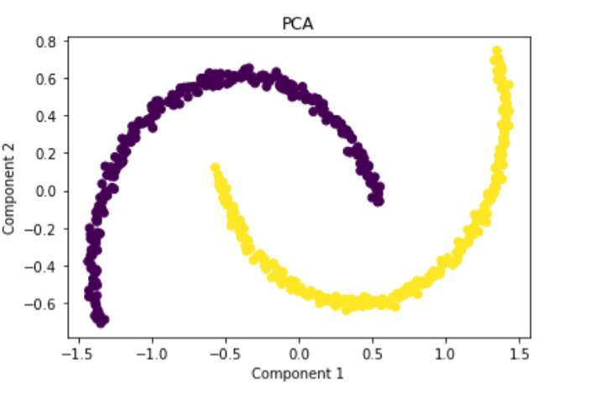

from sklearn.decomposition import KernelPCA

kpca = KernelPCA(kernel ='rbf', gamma = 15)

X_kpca = kpca.fit_transform(X)

plt.title("Kernel PCA")

plt.scatter(X_kpca[:, 0], X_kpca[:, 1], c = y)

plt.show()

**OUTPUT:**

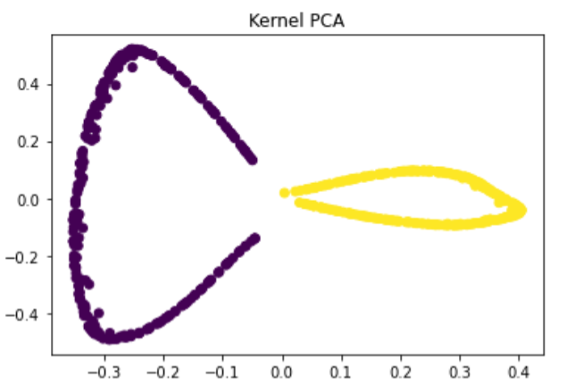

**CODE:**

from sklearn.decomposition import KernelPCA

kpca = KernelPCA(kernel ='rbf', gamma = 5)

X_kpca = kpca.fit_transform(X)

plt.title("Kernel PCA - rbf")

plt.scatter(X_kpca[:, 0], X_kpca[:, 1], c = y)

plt.show()

**OUTPUT:**

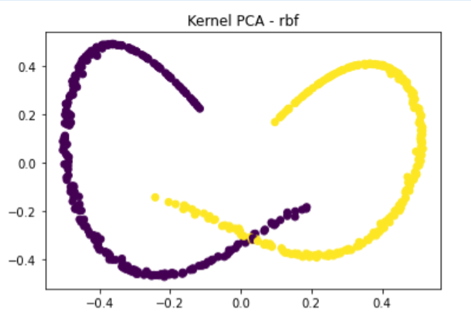

kpca = KernelPCA(kernel ='poly', gamma=15)

X_kpca = kpca.fit_transform(X)

plt.title("Kernel PCA - poly")

plt.scatter(X_kpca[:, 0], X_kpca[:, 1], c = y)

plt.show()

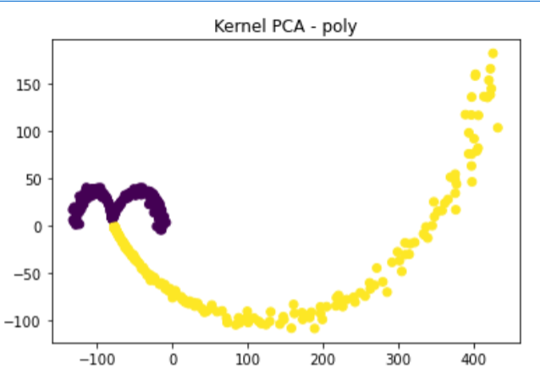

**RESULT:**

The Page Rank algorithm successfully assigned importance scores to each web page based on link structure.

**Exercise 7:Analyzing Graph Data and Identifying Communities**

**Date: 28/09/2024**

**AIM:**

To analyze graph data by calculating centrality measures, identifying key nodes, and detecting communities, helping to understand the graph’s structure and influential nodes.

**Code:**

import pandas as pd

import numpy as np

import networkx as nx

import matplotlib.pyplot as plt

import random

G=nx.karate_club_graph()

nx.draw(G,with_labels=True)

len(G.nodes),len(G.edges)

**OUTPUT:**

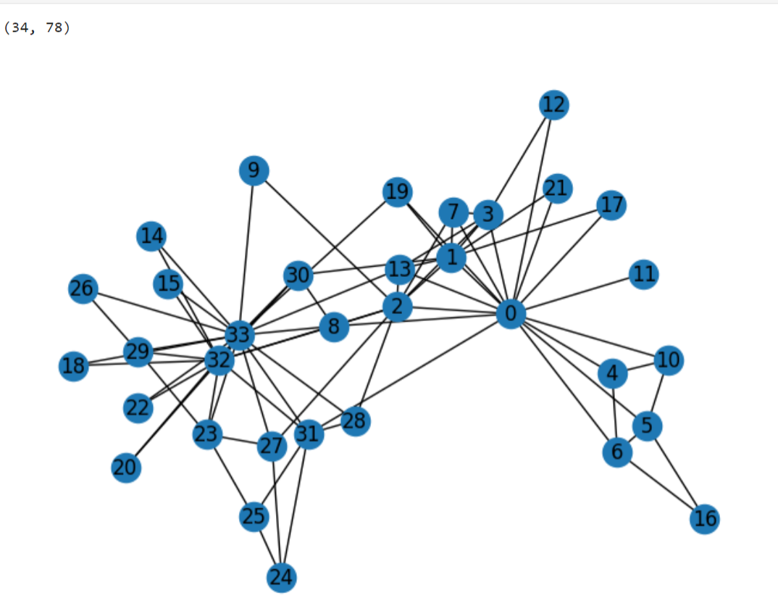

**COMMUNITY DETECTION USING GIRVAN-NEWMAN ARCHITECTURE:**

def edge_to_remove(graph):

edge_betweenness = nx.edge_betweenness_centrality(graph)

return max(edge_betweenness, key=edge_betweenness.get)

def girvan_newman(graph):

sg_count = nx.number_connected_components(graph)

while sg_count == 1:

edge = edge_to_remove(graph)

graph.remove_edge(*edge)

sg_count = nx.number_connected_components(graph)

return nx.connected_components(graph)

c=girvan_newman(G.copy())

node_groups = []

for i in c:

node_groups.append(list(i))

node_groups

color_map = []

for node in G:

if node in node_groups[0]:

color_map.append('red')

else:

color_map.append('green')

nx.draw(G, node_color=color_map, with_labels=True)

plt.show()

**OUTPUT:**

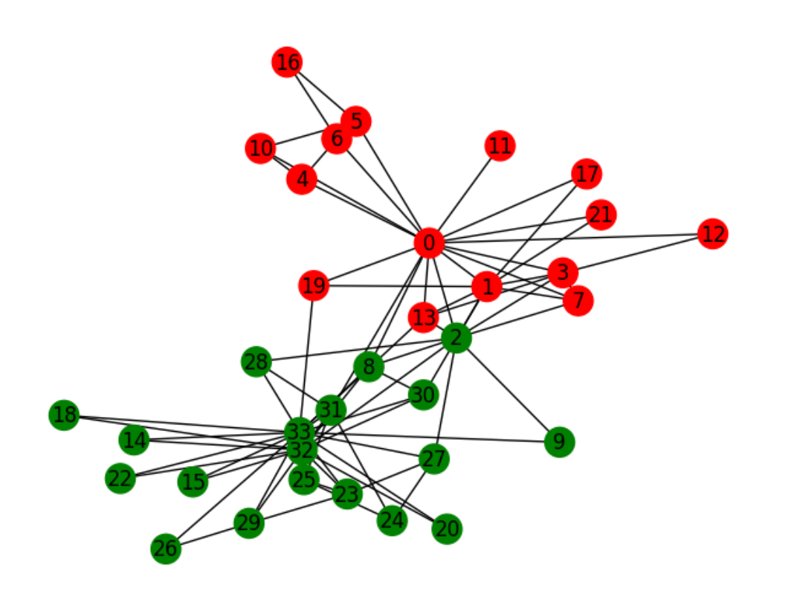

**MODULARITY OF COMMUNITY DETECTION**

from networkx.algorithms.community import modularity

c = girvan_newman(G.copy())

node_groups = []

for community in c:

node_groups.append(list(community))

mod_value = modularity(G, node_groups)

print(f"Node groups (communities): {node_groups}")

print(f"Modularity: {mod_value:.4f}")

**OUTPUT:**



**CODE:**

color_map = []

for node in G:

if node in node_groups[0]:

color_map.append('red')

else:

color_map.append('green')

nx.draw(G, node_color=color_map, with_labels=True)

plt.show()

**OUTPUT:**

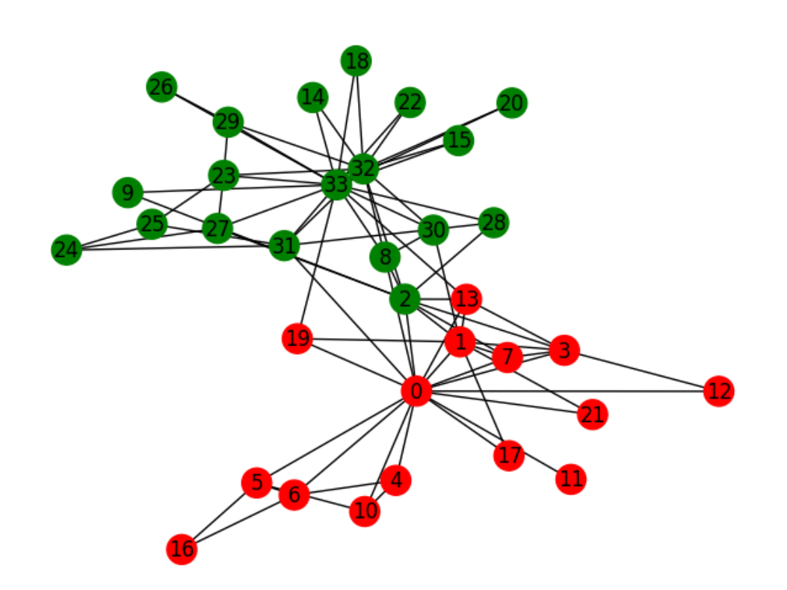

**CALCULATION OF DEGREE CENTRALITY**

degree_centrality=nx.degree_centrality(G)

ranked_nodes=sorted(degree_centrality.items(),key=lambda x:x[1],reverse=True)

print("Nodes ranked by degree centrality:")

for node,centrality in ranked_nodes:

print(f"Node {node}: {centrality:.4f}")

highest_centrality_node=ranked_nodes[0]

print(f"\nNode with the highest degree centrality: Node {highest_centrality_node[0]} with centrality {highest_centrality_node[1]:.4f}")

print("\nThe node with the highest centrality might play a central role in connecting many other nodes. It could indicate that this node is a hub or leader within the network, influencing communication or interactions between others.")

**OUTPUT:**

Nodes ranked by degree centrality:

Node 33: 0.5152

Node 0: 0.4848

Node 32: 0.3636

Node 2: 0.3030

Node 1: 0.2727

Node 3: 0.1818

Node 31: 0.1818

Node 8: 0.1515

Node 13: 0.1515

Node 23: 0.1515

Node 5: 0.1212

Node 6: 0.1212

Node 7: 0.1212

Node 27: 0.1212

Node 29: 0.1212

Node 30: 0.1212

Node 4: 0.0909

Node 10: 0.0909

Node 19: 0.0909

Node 24: 0.0909

Node 25: 0.0909

Node 28: 0.0909

Node 9: 0.0606

Node 12: 0.0606

Node 14: 0.0606

Node 15: 0.0606

Node 16: 0.0606

Node 17: 0.0606

Node 18: 0.0606

Node 20: 0.0606

Node 21: 0.0606

Node 22: 0.0606

Node 26: 0.0606

Node 11: 0.0303

Node with the highest degree centrality: Node 33 with centrality 0.5152

The node with the highest centrality might play a central role in connecting many other nodes. It could indicate that this node is a hub or leader within the network, influencing communication or interactions between others.

**CALCULATION OF BETWEENNESS CENTRALITY:**

betweenness_centrality=nx.betweenness_centrality(G)

ranked_nodes=sorted(betweenness_centrality.items(),key=lambda x: x[1],reverse=True)

print("Top 5 nodes ranked by betweenness centrality:")

for i in range(5):

node,centrality=ranked_nodes[i]

print(f"Node {node}: {centrality:.4f}")

highest_betweenness_node=ranked_nodes[0]

print(f"\nNode with the highest betweenness centrality: Node {highest_betweenness_node[0]} with centrality {highest_betweenness_node[1]:.4f}")

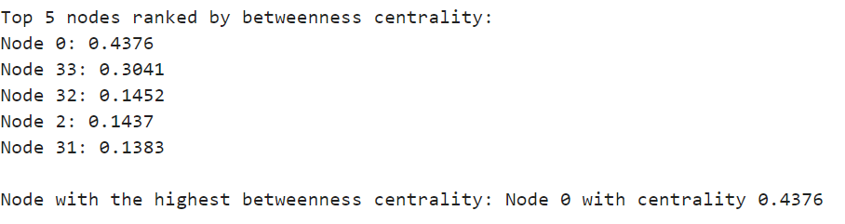

**RESULT:**

Centrality analysis identified key nodes with high influence, while community detection revealed distinct groups within the network

**Exercise No 8:Implementation of Page Rank Algorithm**

**Date:28/09/2024**

**AIM:**

To implement the Page Rank algorithm to rank web pages by analyzing link structure and incorporating teleportation to simulate user behavior.

**CODE:**

import networkx as nx

import matplotlib.pyplot as plt

n = 6

p = 0.4

G = nx.erdos_renyi_graph(n, p, directed=True)

nx.draw(G, with_labels=True, node_color='lightblue', node_size=500, font_size=12, edge_color='gray')

**OUTPUT:**

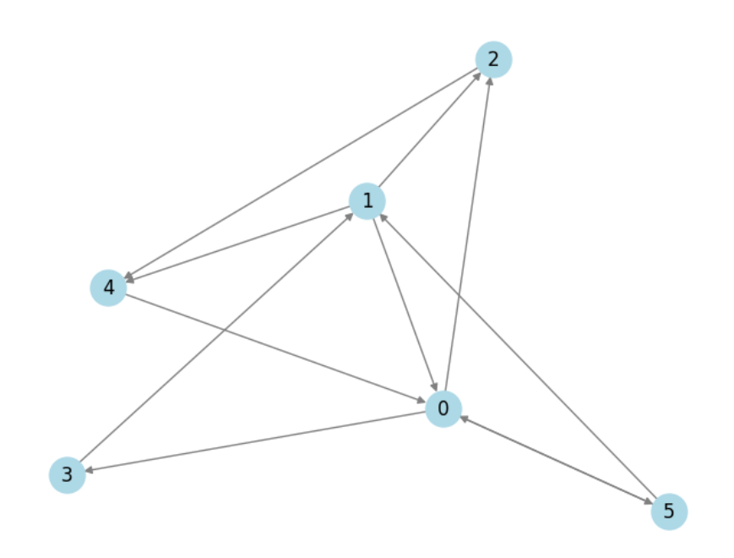

**CODE:**

adj_matrix = nx.adjacency_matrix(G).todense()

print("Adjacency Matrix:\n", adj_matrix)

**CODE:**

def page_rank(graph, damping_factor=0.85, max_iterations=100, tolerance=1e-6):

num_nodes = len(graph)

initial_pr = 1.0 / num_nodes

page_rank = {node: initial_pr for node in graph}

out_degrees = {node: len(graph[node]) for node in graph}

for i in range(max_iterations):

# print(f"Iteration : {i} ")

# print(f"Page Rank : {page_rank}")

prev_page_rank = page_rank.copy()

total_diff = 0.0

for node in graph:

page_rank[node] = (1 - damping_factor) / num_nodes

for neighbor in graph[node]:

page_rank[node] += damping_factor * prev_page_rank[neighbor] / out_degrees[neighbor]

diff = abs(page_rank[node] - prev_page_rank[node])

total_diff += diff

if total_diff < tolerance:

break

return page_rank

**CODE:**

def page_rank(graph, damping_factor=0.85, max_iterations=100, tolerance=1e-06):

num_nodes = len(graph)

page_rank = {node: 1 / num_nodes for node in graph}

prev_page_rank = page_rank.copy()

out_degrees = {node: len(list(graph.successors(node))) for node in graph}

for i in range(max_iterations):

print(f"Iteration : {i} ")

print(f"Page Rank : {page_rank}")

for node in graph:

page_rank[node] = (1 - damping_factor) / num_nodes

for neighbor in graph.predecessors(node):

if out_degrees[neighbor] > 0:

page_rank[node] += damping_factor * prev_page_rank[neighbor] / out_degrees[neighbor]

else:

page_rank[node] += damping_factor * prev_page_rank[neighbor] / num_nodes

diff = sum(abs(page_rank[node] - prev_page_rank[node]) for node in graph)

if diff < tolerance:

break

prev_page_rank = page_rank.copy()

return page_rank

page_rank(G)

**OUTPUT:**

Iteration : 0

Page Rank : {0: 0.16666666666666666, 1: 0.16666666666666666, 2: 0.16666666666666666, 3: 0.16666666666666666, 4: 0.16666666666666666, 5: 0.16666666666666666}

Iteration : 1

Page Rank : {0: 0.2847222222222222, 1: 0.2375, 2: 0.11944444444444445, 3: 0.07222222222222223, 4: 0.2138888888888889, 5: 0.07222222222222223}

Iteration : 2

Page Rank : {0: 0.3047916666666667, 1: 0.11708333333333334, 2: 0.17296296296296296, 3: 0.10567129629629629, 4: 0.19381944444444446, 5: 0.10567129629629629}

Iteration : 3

Page Rank : {0: 0.2678304398148148, 1: 0.15973090277777777, 2: 0.14453125, 3: 0.11135763888888889, 4: 0.20519212962962963, 5: 0.11135763888888889}

Iteration : 4

Page Rank : {0: 0.29199739583333334, 1: 0.16698098958333335, 2: 0.14614238040123456, 3: 0.10088529128086421, 4: 0.19310865162037036, 5: 0.10088529128086421}

Iteration : 5

Page Rank : {0: 0.27932988305362655, 1: 0.15362874638310187, 2: 0.15504387586805557, 3: 0.10773259548611111, 4: 0.19653230372299382, 5: 0.10773259548611111}

Iteration : 6

Page Rank : {0: 0.28136695605468753, 1: 0.1623590592447917, 2: 0.1476716116737397, 3: 0.1041434668651942, 4: 0.20031543929639278, 5: 0.1041434668651942}

Iteration : 7

Page Rank : {0: 0.2855308302723324, 1: 0.1577829202531226, 2: 0.1507223710015191, 3: 0.10472063754882814, 4: 0.19652260337536973, 5: 0.10472063754882814}

Iteration : 8

Page Rank : {0: 0.28125564456570096, 1: 0.1585188128747559, 2: 0.15060556264887892, 3: 0.10590040191049419, 4: 0.19781917608967597, 5: 0.10590040191049419}

Iteration : 9

Page Rank : {0: 0.2830676341360321, 1: 0.16002301243588007, 2: 0.14960276294146277, 3: 0.10468909929361528, 4: 0.1979283918993946, 5: 0.10468909929361528}

Iteration : 10

Page Rank : {0: 0.2830718538377713, 1: 0.15847860159935948, 2: 0.15054234986204176, 3: 0.10520249633854242, 4: 0.1975022020237427, 5: 0.10520249633854242}

Iteration : 11

Page Rank : {0: 0.2824902031172136, 1: 0.15913318283164157, 2: 0.1501059623738537, 3: 0.10520369192070186, 4: 0.19786326783588737, 5: 0.10520369192070186}

Iteration : 12

Page Rank : {0: 0.28298308186243437, 1: 0.1591347071988949, 2: 0.1501266260188423, 3: 0.10503889088321053, 4: 0.19767780315340744, 5: 0.10503889088321053}

Iteration : 13

Page Rank : {0: 0.28275582834544766, 1: 0.15892458587609343, 2: 0.15026670690070995, 3: 0.10517853986102307, 4: 0.19769579915570284, 5: 0.10517853986102307}

Iteration : 14

Page Rank : {0: 0.2827709413881754, 1: 0.15910263832280444, 2: 0.15014278402943665, 3: 0.10511415136454351, 4: 0.19775533353049657, 5: 0.10511415136454351}

Iteration : 15

Page Rank : {0: 0.282844628688981, 1: 0.15902054298979298, 2: 0.1501975142514443, 3: 0.10511843339331636, 4: 0.19770044728314906, 5: 0.10511843339331636}

Iteration : 16

Page Rank : {0: 0.2827765348966108, 1: 0.15902600257647836, 2: 0.15019513197565265, 3: 0.10513931146187797, 4: 0.19772370762750233, 5: 0.10513931146187797}

Iteration : 17

Page Rank : {0: 0.28280672625134395, 1: 0.15905262211389443, 2: 0.1501773856173753, 3: 0.10512001822070641, 4: 0.19772322957597363, 5: 0.10512001822070641}

Iteration : 18

Page Rank : {0: 0.28280566248231453, 1: 0.15902802323140067, 2: 0.15019348203681754, 3: 0.10512857243788079, 4: 0.19771568737370576, 5: 0.10512857243788079}

Iteration : 19

Page Rank : {0: 0.28279591746931276, 1: 0.159038929858298, 2: 0.15018621095221932, 3: 0.10512827103665578, 4: 0.19772239964685842, 5: 0.10512827103665578}

Iteration : 20

Page Rank : {0: 0.2828045850169262, 1: 0.15903854557173613, 2: 0.1501865400761564, 3: 0.10512550994963862, 4: 0.1977193094359042, 5: 0.10512550994963862}

Iteration : 21

Page Rank : {0: 0.28280067599444025, 1: 0.15903502518578927, 2: 0.150188887000121, 3: 0.10512796575479576, 4: 0.19771948031005815, 5: 0.10512796575479576}

Iteration : 22

Page Rank : {0: 0.2828008675119779, 1: 0.1590381563373646, 2: 0.15018678200106503, 3: 0.10512685819842474, 4: 0.19772047775274315, 5: 0.10512685819842474}

Iteration : 23

Page Rank : {0: 0.2828021317864155, 1: 0.15903674420299155, 2: 0.1501877234239804, 3: 0.10512691246172709, 4: 0.19771957566315856, 5: 0.10512691246172709}

Iteration : 24

Page Rank : {0: 0.2828009879674331, 1: 0.15903681338870204, 2: 0.150187681530332, 3: 0.10512727067281773, 4: 0.1977199757678976, 5: 0.10512727067281773}

Iteration : 25

Page Rank : {0: 0.2828014998987927, 1: 0.1590372701078426, 2: 0.15018737705090496, 3: 0.10512694659077271, 4: 0.19771995976091444, 5: 0.10512694659077271}

Iteration : 26

Page Rank : {0: 0.2828014779617444, 1: 0.1590368569032352, 2: 0.15018765150188002, 3: 0.10512709163799128, 4: 0.19771983035715796, 5: 0.10512709163799128}

[5]:

{0: 0.28280131253898055,

1: 0.15903704183843886,

2: 0.15018752821174422,

3: 0.10512708542249424,

4: 0.19771994656584801,

5: 0.10512708542249424}

**CODE:**

nx.pagerank(G)

**GOOGLE WEB GRAPH:**

**CODE:**

file_path = "/content/drive/MyDrive/DATA ANALYTICS LAB/Datasets/web-Google.txt"

edges = pd.read_csv(file_path, sep="\t", comment='#', header=None, names=['FromNodeId', 'ToNodeId'])

**CODE:**

edges.values

**OUTPUT:**

**CODE:**

G = nx.DiGraph()

G.add_edges_from(edges.values)

num_nodes = G.number_of_nodes()

num_edges = G.number_of_edges()

density = nx.density(G)

avg_in_degree = sum(dict(G.in_degree()).values()) / num_nodes

avg_out_degree = sum(dict(G.out_degree()).values()) / num_nodes

print(f"Number of nodes: {num_nodes}")

print(f"Number of edges: {num_edges}")

print(f"Density of the graph: {density:.5f}")

print(f"Average in-degree: {avg_in_degree:.2f}")

print(f"Average out-degree: {avg_out_degree:.2f}")

**OUTPUT:**

**CODE:**

in_degrees = dict(G.in_degree())

out_degrees = dict(G.out_degree())

plt.figure(figsize=(12, 5))

plt.subplot(1, 2, 1)

plt.hist(in_degrees.values(), bins=50, color='lightblue', edgecolor='black')

plt.title("In-Degree Distribution")

plt.xlabel("In-Degree")

plt.ylabel("Frequency")

plt.subplot(1, 2, 2)

plt.hist(out_degrees.values(), bins=50, color='lightgreen', edgecolor='black')

plt.title("Out-Degree Distribution")

plt.xlabel("Out-Degree")

plt.ylabel("Frequency")

plt.tight_layout()

plt.show()

**OUTPUT:**

**CODE:**

sccs = list(nx.strongly_connected_components(G))

print(f"Number of strongly connected components: {len(sccs)}")

largest_scc = max(sccs, key=len)

print(f"Size of the largest strongly connected component: {len(largest_scc)}")

Number of strongly connected components: 371764

Size of the largest strongly connected component: 434818

pagerank_scores = nx.pagerank(G, alpha=0.85)

top_10_pagerank = sorted(pagerank_scores.items(), key=lambda item: item[1], reverse=True)[:10]

print("\nTop 10 nodes by PageRank score:")

for node, score in top_10_pagerank:

print(f"Node {node}: {score:.6f}")

**OUTPUT:**

**RESULT:**

The Page Rank algorithm computed importance scores for each web page, successfully converging after several iterations, with more influential pages receiving higher ranks due to inbound link quality and quantity.